

NEW ZEALAND **IMMIGRATION**

Claiming Refugee and Protection Status in New Zealand

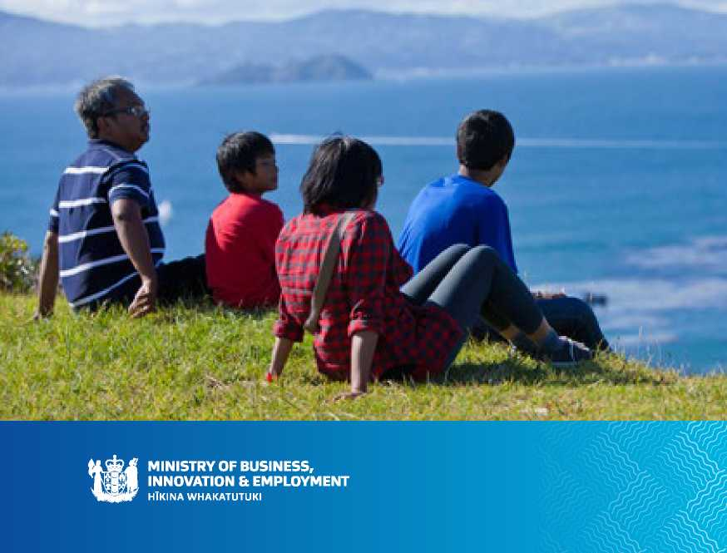



This booklet explains how New Zealand considers claims for refugee or protected person status (asylum).

Contents

Refugee and Protection Claim Process Map 2

Introduction 3

1. What is a refugee and a protected person? 4
2. The asylum procedure 5
   1. Representation 5
   2. Lodging your asylum claim 6
   3. At the Refugee Status Branch 6
   4. The decision 10
   5. Additional information 11
   6. Subsequent refugee and protection claims 12
3. Rights and responsibilities of asylum-seekers 13

3.1 Your rights 13

3.2 Your responsibilities 13

Glossary 15

Contacts 16

Refugee and Protection Claim

Process Map

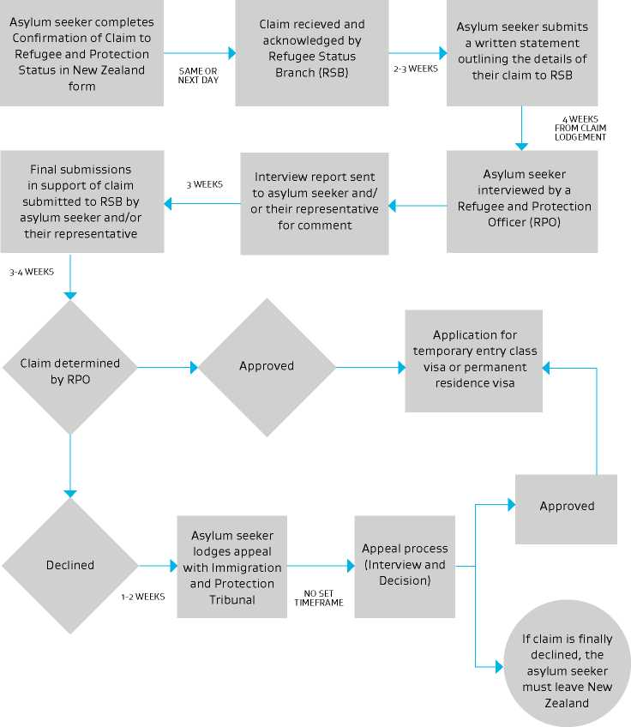

Introduction

You have claimed asylum in New Zealand. The purpose of this brochure is to provide information on the refugee and protection claim process, as well as your rights and responsibilities.

An asylum seeker is a person who fears returning to his or her home country and seeks refugee or “protected person” status.

In New Zealand asylum claims are decided according to the Immigration Act 2009 (the Act). One of the purposes of the Act is to ensure that New Zealand meets its obligations under the 1951 Convention Relating to the Status of Refugees, the 1984 Convention against Torture and Other Cruel, Inhuman or Degrading Treatment or Punishment or under the 1966 International Covenant on Civil and Political Rights.

Your claim will be decided by the Refugee Status Branch, which is a part of Immigration New Zealand (INZ). You cannot be deported from New Zealand while your asylum claim is being processed.

If you are recognised as a refugee or protected person, you are allowed to stay in New Zealand. If you are not recognised as a refugee or protected person, you have to leave New Zealand.

The asylum process is confidential per section 151 of the Act. The information you provide during your claim will be kept confidential to the New Zealand Government and the United Nations High Commissioner for Refugees (UNHCR) but may be disclosed to others when necessary for lawful purposes. The Refugee Status Branch has a duty to inquire into your claim and may disclose some information for this purpose, or for other reasons, such as to investigate offences. Information would only be disclosed if there is no serious possibility that your safety or any other person's would be endangered.

1. What is a refugee and a protected person?

Refugee and protected person status is a legal status. Refugees are people who meet the definition of a refugee provided in the 1951 Convention Relating to the Status of Refugees, as amended by the 1967 Protocol.

A protected person is a person whose deportation from New Zealand would violate the Convention against Torture and Other Cruel, Inhuman or Degrading Treatment 1984 (Convention against Torture) and/or the International Covenant on Civil and Political Rights 1966 (ICCPR).

Broadly speaking a refugee is a person who:

* Is outside of his or her home country or country of habitual residence
* Faces a real chance of being harmed if returned to that country
* The harm faced is a sustained or systemic breach of a fundamental human right
* The harm faced is for reasons of who the person is, or what they believe. The reasons may be race (or ethnicity), religion, political opinion, nationality or membership of a particular social group (such as family status, gender, or sexual orientation or identity)

> Needs and deserves protection in New Zealand.

A protected person is a person for whom there are substantial grounds for believing she or he would be in danger of torture, arbitrary deprivation of life or cruel treatment if deported from New Zealand.

Cruel treatment is defined in the Act as cruel, inhuman or degrading treatment or punishment1.

If a person can obtain effective protection from the authorities of their country or a third country, New Zealand is not obliged to protect them.

A person may be excluded from refugee status if there are serious reasons for considering that he or she has committed serious crimes such as war crimes or crimes against humanity.

Section 131(6).

1. The asylum procedure

The authorities involved in processing your claim for asylum in New Zealand are as follows:

* The Refugee Status Branch (RSB)
* The Immigration and Protection Tribunal (Tribunal)

The RSB will decide your claim to refugee and protection status. If the RSB declines your claim, you generally have the right to appeal that decision to the Tribunal.

You can claim asylum:

* When you arrive in New Zealand (eg at the airport or a seaport)
* In New Zealand by advising a government official such as an immigration officer or a refugee and protection officer, or a police constable that you intend to claim asylum

1. REPRESENTATION

A representative is someone who can advise you on the laws that apply to your claim for asylum, and help you through the process. You may wish to talk to a representative before lodging a claim for asylum.

If you want to employ a representative, you should make sure you use either a lawyer (a person who holds a current practising certificate as a barrister or as a barrister and solicitor, issued by the New Zealand Law Society) or an immigration adviser who is licensed by the Immigration Advisers Authority. This will ensure that your representative is properly qualified to advise you and meets approved standards.

If you want a representative to help you, you should find one quickly, because your claim will not normally be delayed in order for you to find a representative.

If you have no money to pay for a lawyer, you may qualify for free legal advice through an official scheme known as legal aid.

Legal Aid

The Legal Aid Scheme is a government fund for providing people with legal help when they cannot afford to hire a lawyer to represent them. To get legal aid you have to make an application to the Legal Services Agency (LSA) - your lawyer will do this.

Not all lawyers do legal aid work.

Some lawyers may answer questions about legal aid for free, but you should always check this with the lawyer when you start talking to them.

For more information:

The Ministry of Justice has a list of legal aid lawyers on its website at: http:// www2.justice.govt.nz/find-a-legal- aid-lawyer/. To search for lawyers who are experienced in refugee matters you must enter “Law Type: Refugee & Immigration” into the search function.

For more information about how the legal aid system works visit: http:// [www.justice.govt.nz/services/legal- help/legal-aid](http://www.justice.govt.nz/services/legal-help/legal-aid).

Community Law centres also provide legal information and advice, assistance and representation for people who cannot afford to pay for legal services.

For further information visit: http:// [www.communitylaw.org.nz/](http://www.communitylaw.org.nz/)

The RSB can also give you information on finding a lawyer.

You can search for a licensed immigration adviser on the Immigration Advisers Authority website: <http://iaa.govt.nz/>. You will need to pay a fee for a licensed immigration adviser.

1. **LODGING YOUR ASYLUM CLAIM Confirmation of Claim to Refugee and Protection Status in New Zealand form (INZ 1070)**

**You must confirm your claim in writing by completing the Confirmation of Claim to Refugee and Protection Status in New Zealand (Confirmation of Claim) form.** This form can be downloaded from the RSB website: <http://www.immigration.govt>. nz/branch/RSBHome/

The Confirmation of Claim must be completed in English, and you must answer every question in the form. You must submit the form to the RSB, either in person or by mail to:

Refugee Status Branch

Level 12, 280 Queen Street, Auckland CBD

OR

PO Box 90533, Victoria Street, Auckland 1142, DX: CX10074

Please note you cannot submit the Confirmation of Claim form electronically via email or the internet.

If you are part of a family group, a separate form must be submitted for each family member (including one for each child) who wants to claim asylum.

If you have a representative they will help you to complete the Confirmation of Claim form.

Supporting documents

Make sure you submit any identity documents you have with you, including your passport, driver's license and any other documents, with your Confirmation of Claim form.

If you arrive in New Zealand without any valid identity documents, you may be detained while your claim is being processed.

Retain all important documents! They could be important for the assessment of your claim.

Your address

You must provide the RSB with the address and telephone number of where you are staying in New Zealand. If you change your address while your claim is being processed, you must advise the RSB of your new address.

Correspondence

If you have a representative, all correspondence regarding your claim will be sent to your representative.

If you do not have a representative

If you do not have a representative there is some information you should know:

* You will be issued a unique

Client Number (for example “CN: 12345678”). You should write your Client Number on any correspondence you send to the RSB and other branches of INZ.

* You can request a copy of your immigration file. This includes all visa applications you may have made to INZ. To request a copy of your file contact the RSB:

In person at: Level 12, 280 Queen Street, Auckland CBD

Mail: PO Box 90533, Victoria Street, Auckland 1142, DX: CX10074

Phone: 09 914 5999

Email: [RSB@mbie.govt.nz](mailto:RSB@mbie.govt.nz) (in the subject line please write: “File

Request”, and you should include your full name and Client Number in the body of the email)

1. AT THE REFUGEE STATUS BRANCH

Your claim will be assigned to a refugee and protection officer (RPO).

The RPO aims to decide your claim within 140 days (or 20 weeks) of the date that your Confirmation of Claim form was lodged with the RSB.

There are four stages to the claim process at the RSB:

1. Submit a written statement

After you have lodged your claim you must provide a full, written statement of your experiences and circumstances that have led you to claim refugee and protection status. **Your statement should be submitted to the RSB at least one (1) week before your interview.**

If you have a representative they will help you to write your written statement. Your statement must be in English and any events should be dated. The English translation of your written statement must:

* be certified as a correct translation made by a person familiar with both languages and competent in translation work
* be on the official letterhead of the translation service or
* bear the stamp or signature of the translator and
* be accompanied by the original documents or certified copies

Your written statement must not be translated by a family member or a person with an interest in the outcome of your claim.

The RSB can provide you with more information about what should be in the written statement if required.

1. The interview

The RPO will interview you about your claim approximately four (4) weeks after you have lodged your claim.

At the interview you will be asked about:

* yourself, your family and your home country
* why you fear returning to your home country

The interview is your chance to tell us why you are claiming asylum in New Zealand. You must be able to satisfy the RPO about who you are and the country you are from. Under Section 135 of the Act it is your responsibility to establish your claim. **You must ensure that you provide all information that may be important to your case, even if no direct question is asked.**

Providing incorrect information, or concealing relevant information, is a criminal offence. If you provide any incorrect information to the RPO processing your claim, it may cause him/her to doubt other information that you have given.

The interview at the RSB is a key moment in your claim. It is important to tell the truth, because false or misleading statements may lead to your claim being disbelieved.

It is your responsibility to provide all information, evidence and submissions that you wish to have considered in support of your refugee and protection claim. Some examples of useful documents include:

* your passport, and the passport(s) of your spouse and any dependants in New Zealand
* police clearance certificates, if you or any members of your family have them
* other documents which will help us to establish your identity and nationality - these may include identity cards, birth certificates, marriage certificates, school certificates, military service documents and membership cards

> any other documents that will support your claim

You should provide certified translations of all documents you wish to submit in support of your claim.

If the RPO obtains any information which is prejudicial to your claim, he/ she will disclose it to you and you will have the opportunity to comment on that information.

Your interview will be recorded electronically and the RPO will also make a written record of the interview. You can request a copy of the recording and the RPO's interview notes afterwards.

Most interviews are held from 9:00am to 5:00pm at the RSB office in Auckland. Sometimes interviews are held in Wellington and Christchurch.

If you are detained you will be interviewed at the place where you are being detained (in prison or at the Mangere Refugee Resettlement Centre).

If you are part of a family group, each adult family member will be interviewed by the RPO separately. If your family group includes minors (under 18 years), the RPO will advise you whether the minors should attend the interview and if they will be questioned. Please note young children cannot stay with you in the interview room while you are being interviewed, and it is your responsibility to arrange for your children to be cared for while you are being interviewed.

**Representative**

If you have a representative they may attend the interview with you.

**Interpreter**

If you need one, the RSB will provide an independent interpreter in a language which you can speak and understand. The interpreter will translate everything you say and everything that the RPO says. The interpreter is not involved in the decision-making process. Interpreters must keep all information confidential so you should not fear telling the RPO any details of your claim.

If there are any issues with interpretation at your interview, it is your responsibility to raise this matter with the RPO or your representative at the interview.

**Biometrics**

The RPO may require you to allow biometric information (fingerprints and photograph) to be collected from you. This usually occurs before the interview.

For more information on biometrics see the Immigration Fingerprint and Photograph Check leaflet.

**Support person**

You may request a support person other than your representative to attend your interview. Your request must be made in writing at least one week before the interview and must explain why you require a support person and what your relationship is with that person, to enable the RPO to decide whether they can attend. Any support person or observer will be required to sign an observer confidentiality agreement.

**Attending the interview**

It is very important that you attend your interview. If you fail to attend your interview the RPO will be unable to make any findings of fact or credibility. Your claim may therefore be determined on the basis of all information available to the RPO. **What to do if you are unwell on the day of interview**

If you are unable to attend your interview because of illness or disability, you must notify the RSB immediately. You must also supply a medical certificate from a registered medical practitioner no later than 4:00pm on the day of your scheduled interview. To be acceptable, the medical certificate must specify:

1. your illness or disability
2. the expected duration of the illness or disability
3. the reason, in the opinion of the medical practitioner, why you are unable to attend the interview and
4. the medical practitioner's opinion as to when you will be fit and able to attend an interview

If the RSB determines that the medical certificate meets the above criteria, then the interview may be rescheduled.

**What to do if you are unable to attend your interview for any other reason**

10

If you are unable to attend your interview for any other reason, written supporting evidence must be provided to the RSB at least five (5) working days before the scheduled interview date. If your request is accepted, your interview will be rescheduled for the earliest possible date.

1. Interview Report and final submissions

After your interview the RPO will write a report (Interview Report) summarising your claim within three (3) weeks. The report will be sent to you and/or your representative.

When you receive the Interview Report you have three (3) weeks to comment on that report and to make any further submissions in support of your claim.

If the Interview Report is sent to you, and it is returned to the RSB because the address is incorrect or you no longer live at that address and the RSB does not have a current address for you, the RPO may proceed straight to writing a decision on your claim.

It is very important that you read the Interview Report carefully, and in your response state whether you agree that it is a correct summary of what you have told the RPO. If it is not correct, you need to state what information is wrong and what it should say. You should also answer any further questions or concerns raised in the Interview Report.

If you have a representative they will assist you to respond to the Interview Report.

You can provide information in support of your claim up until the date your claim is decided.

1. Decision

The RPO will send you or your representative a copy of the decision on your claim.

The RPO assesses each claim on its merits. The RPO will make the decision based on all the information you have provided, and any other information he/she has about you or your home country. The RPO will assess:

1. Are your statements truthful/ credible?

2. Does your claim meet the criteria contained in Article 1A(2) of the Refugee Convention or are you eligible for protected person status?

1. THE DECISION

The RPO will either approve or decline your claim.

**If you are recognised as a refugee or protected person**

Recognition as a refugee or protected person means that you are allowed to stay in New Zealand. You can apply to the nearest Visa Branch of INZ if you wish to apply for a temporary entry class visa or a permanent resident visa. You will receive further information from RSB about residence visa applications and settling in New Zealand.

Adults who are recognised as refugees or protected persons will first be granted work visas. School-aged children will generally be granted student visas, which allow study at any primary and/or secondary school. Dependent children who are not in school will be granted a visitor visa. You can then apply for a permanent resident visa. A residence visa can take time to process and is a separate and additional step. Refugee or protection status does not guarantee a residence visa.

If you are not recognised as a refugee or protected person

If you do not meet the criteria for recognition as a refugee and you are also denied protected person status, you will receive a decision explaining the reasons for this refusal.

You will be told what rights you may have to appeal the RPO's decision and the time limits for this. Claims that are declined may generally be appealed to the Tribunal.

If you have a representative they may assist you with your appeal to the Tribunal.

If you lodge an appeal a copy of your INZ file, including all information provided by you and your representative to RSB in support of your claim, will be sent to the Tribunal. If you lodge an appeal you cannot be deported from New Zealand until that appeal has been determined.

For more information on appeals visit the Tribunal's website: <http://www.justice.govt.nz/tribunals/> immigration-protection-tribunal/

If your appeal is unsuccessful

If your appeal is unsuccessful and it is finally determined that you are not a refugee or protected person, you are required to leave New Zealand.

You or your representative should contact the Compliance Branch of INZ to discuss your options:

Phone: (09) 918 4474 and (09) 914 5740

1. **ADDITIONAL INFORMATION**

What to do if you no longer wish to seek asylum

At any stage of the process, you are free to leave New Zealand voluntarily. If you leave New Zealand while your claim is being processed, your claim is deemed to have been withdrawn. You may also withdraw your claim at any stage of the process by advising the RPO in writing of the reasons for your withdrawal.

You should be aware that a person who is declined refugee and protected person status in New Zealand may not apply for any further type of visa while in New Zealand. This includes applications for: student, work, skilled migrant, business and residence visas. This only applies to people whose refugee and protection claim has been declined. However, a person who lodges a claim and then withdraws that claim before the date of determination may make further visa applications in New Zealand.

The United Nations High Commissioner for Refugees

12

UNHCR in Australia acts as a monitoring body for the refugee status determination process in New Zealand. You can find more information about UNHCR on its website: [www.unhcr.org](http://www.unhcr.org)

Cancellation of refugee or protection status

If it is established that you have obtained asylum on the basis of false statements or forged documents, the RSB may decide to cancel your refugee or protection status.

The cancellation process mirrors the four step process outlined above for determining claims at the RSB.

If your refugee or protection status is cancelled you will be told what rights you may have to appeal the RPO's decision and the time limits for this. Cancellation of refugee and protection status by RPOs may generally be appealed to the Tribunal.

In certain circumstances an RPO can also cease to recognise you as a refugee or protected person (if the grant of refugee or protection status is no longer necessary or justified). This process mirrors the cancellation process.

1. SUBSEQUENT REFUGEE AND PROTECTION CLAIMS

A subsequent refugee and protection claim refers to a situation where a person's claim has been declined by the RSB and/or their appeal to the Tribunal has been unsuccessful and they have lodged a further claim for refugee and protection status.

For a subsequent claim to be considered it must meet certain criteria. The RPO must be satisfied that:

* there has been a significant change in circumstances material to the claim since the previous claim was determined; and
* the change in 1 or more of the circumstances was not brought about by the asylum seeker—
* acting otherwise than in good faith; and
* for a purpose of creating grounds for recognition as a refugee or protected person.

The RPO may refuse to consider a subsequent claim if they are satisfied that the claim:

* is manifestly unfounded or clearly abusive; or
* repeats any claim previously made (including a subsequent claim).

1. Rights and responsibilities of asylum-seekers

3.1 YOUR RIGHTS

As an asylum seeker in New Zealand, you have the right to:

* remain in New Zealand until your claim for refugee and protection status is finally decided
* be treated fairly and lawfully regardless of your race, gender, age, religion, sexual orientation or any disability
* have your claim considered fairly and accurately
* advice or representation. Free legal help may be available, depending on your case. See the Representation section for more information.
* access publicly funded health care (please note that everyone in New Zealand must pay to see a doctor, except children under six (6), who go for free)
* practise your own religion
* be issued with an identity document if you do not have a valid travel document

If you are issued with a work visa you have the right to:

* engage in wage earning employment (for information on worker's rights see: http:// mbie.govt.nz/ and visit the page on “Labour and Employment Relations”).

If you are issued with a visa (work, visitor or student) you have the right to:

* access financial support from Work and Income if you meet the requirements (visit your local Work and Income office to see if you are eligible for assistance)
* freedom of association
* freedom of movement
* attend school

For more information on support services see the Services for Asylum Seekers brochure.

3.2 YOUR RESPONSIBILITIES

As an asylum seeker it is your responsibility to:

* act in good faith, co-operate with the RSB and tell the truth. It is a crime to provide false information to an RPO
* provide us with your biometric information if the RPO requests it
* stay in contact with the RPO deciding your claim, or your representative if you have one, including keeping all your appointments and informing the RPO if you are unable to attend the interview
* provide RSB with a current physical > address, and notify RSB if you change your address while your claim is being processed

14

* provide all information, evidence and submissions that you

wish to have considered in the determination of your refugee and protection status

* ensure your visa is kept valid while your claim is being processed

(if you have a visa). This can be done by applying to your nearest Visa Branch of INZ. For further information, please phone the Immigration Contact Centre on (09) 914 4100 (Auckland) or 0508 55 88 55 (rest of New Zealand) or visit [www.immigration.govt.nz](http://www.immigration.govt.nz) obey the law, including respecting the rights of others to freedom of religion and freedom from discrimination

* care for your children if they are in New Zealand (for example, an adult must always supervise children under the age of 14, and if they are aged between six (6) and 16 they must attend school)
* leave New Zealand if your claim and any appeal you make is unsuccessful. You should also note that if it is finally determined that you are not a refugee or protected person, you are no longer eligible for subsidised healthcare in New Zealand.

Glossary

15

**Asylum seeker:** A person who says he or she is a refugee or protected person, but whose claim has not yet been decided.

**Convention refugee:** An asylum seeker who has been recognised as a refugee. A refugee is someone who owing to a well-founded fear of being persecuted for reasons of race, religion, nationality, membership of a particular social group or political opinion, is outside the country of his or her nationality, and is unable to, or owing to such fear, is unwilling to avail himself or herself of the protection of that country.

**Protected person:** A person who does not meet the criteria to be recognised as a refugee, but for whom there are substantial grounds for believing that they would be in danger of being subjected to arbitrary deprivation of life, torture or cruel, inhuman or degrading treatment or punishment, if deported from New Zealand. This person also cannot access meaningful domestic protection in his or her home country or country of former habitual residence.

**Quota refugee:** A person determined to be a refugee by the United Nations High Commissioner for Refugees (UNHCR) before arriving in New Zealand. The ‘quota' also includes applicants for Refugee Quota Family Reunification. These are people who have not usually been recognised as refugees, but are in ‘refugee like' situations, and a sponsor has applied to have the person settle in New Zealand. The sponsor must have been recognised as a refugee by UNHCR, and been granted a Permanent Resident Visa in New Zealand as part of the Refugee Quota Programme. The person nominated must be an immediate family member of the sponsor, and must have been declared in the sponsor's original application for permanent residence. The sponsor must also be living in New Zealand, and meet relevant character requirements.

**Representative:** A person who can advise you on the laws that apply to your refugee and protection claim, and help you to deal with INZ. This person must be a lawyer (a person who holds a current practising certificate as a barrister or as a barrister and solicitor, issued by the New Zealand Law Society), or an immigration adviser who is licensed by the Immigration Advisers Authority.

**Legal Aid:** A Government fund for providing people with legal help when they cannot afford to hire a lawyer to represent them.

**Biometric information:** A photograph of all or part of a person's head and shoulders, the person's fingerprints, an iris scan.

Refugee Status Branch

16

Contacts

Level 12, 280 Queen Street,

Auckland CBD

Postal address: PO Box 90533, Victoria

Street, Auckland 1142, DX: CX10074

Telephone: 09 928 2236

Fax: 09 914 5298

Email: [RSB@mbie.govt.nz](mailto:RSB@mbie.govt.nz)

Website: [www.immigration.govt.nz/](http://www.immigration.govt.nz/) branch/RSBHome/

Immigration New Zealand

Immigration Contact Centre

Telephone (from Auckland):

09 914 4100

Telephone (from anywhere else in New

Zealand): 0508 55 88 55

Website: [www.immigration.govt.nz](http://www.immigration.govt.nz)

Immigration and Protection Tribunal

Chorus House, Level 1, 41 Federal Street, Auckland 1010,

Postal address: DXEX 11086, Auckland 1142, New Zealand

Telephone: 09 914 4299

Fax: 09 914 5263

Email: [IPT@justice.govt.nz](mailto:IPT@justice.govt.nz)

Website: [www.justice.govt.nz/](http://www.justice.govt.nz/) tribunals/immigration-protection- tribunal

United Nations High Commissioner for Refugees

Legal Officer

UNHCR Regional Office for Australia, New Zealand, Papua New Guinea and the South Pacific

14 Kendall Lane

New Acton, Canberra ACT, 2601

AUSTRALIA

Telephone: 0061 2 6281 9100

Fax: 0061 2 6247 2933

Website: [www.unhcr.org](http://www.unhcr.org)

17



*n >anf 6o8?:i an